SSi MCP Server
High-Level Design (HLD) | Version 3.0

A concise architecture guide for interns and developers

Executive Summary
SSi already provides market intelligence through production REST APIs. The SSi MCP Server will expose selected APIs as tools that AI assistants can discover and invoke through the Model Context Protocol (MCP). It will remain a thin, secure integration layer: all analytics and business logic continue to reside in the existing SSi platform.

What is MCP?
The Model Context Protocol (MCP) is an open standard that allows AI applications to connect to external tools and data sources through a consistent interface. An MCP-compatible AI client can discover available tools, understand their inputs, invoke them and use the returned results in a conversation.
Concept | Meaning
MCP Client | An AI application such as ChatGPT, Claude or another compatible assistant.
MCP Server | A service that publishes tools and handles MCP requests.
MCP Tool | A callable capability such as get_daily_graphs.
Tool Discovery | The process by which the AI client learns which tools are available.
Tool Invocation | Execution of a tool with validated parameters.

Why MCP?
Without MCP, SSi may need separate integrations for each AI platform. With MCP, SSi implements one standards-based integration that can be reused across multiple compatible clients. This reduces duplication, simplifies maintenance and keeps the existing REST APIs unchanged.

Why SSi Needs an MCP Server
The existing Daily Graph APIs were designed for application-to-application REST integration. AI assistants need a structured way to discover capabilities and invoke them safely. The MCP Server fills this gap by translating MCP tool calls into existing HTTPS REST requests and converting API responses back into MCP-compliant results.
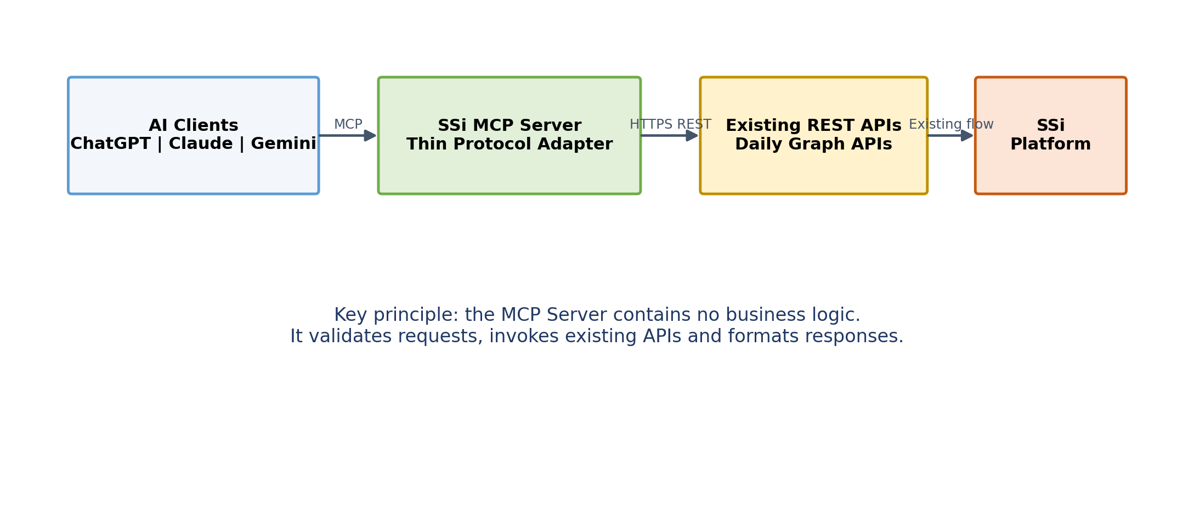
Figure 1: High-level component architecture. AI clients call the SSi MCP Server, which calls existing REST APIs; the MCP Server holds no business logic.

Design Goals
Goal | Design Intent
Reuse existing APIs | No changes to existing Daily Graph APIs or SSi business logic.
Thin integration layer | Only protocol handling, validation, authentication, logging and response formatting.
Standards based | Use MCP tool discovery and invocation.
Secure | Authenticate AI clients and protect downstream API access.
Extensible | Add future tools without redesigning the server.
Platform independent | Support multiple MCP-compatible clients.

Key Architectural Decision
The MCP Server must not calculate sentiment, price trends or any other SSi analytics. It is an adapter, not a second application layer.

Scope and MCP Tools
MCP Tool | Existing REST Endpoint | Purpose
get_daily_graphs | /daily-graphs | Retrieve Daily Graphs data.
get_daily_graphs_60_90_days | /daily-graphs-60-90-days | Retrieve 60-day and 90-day historical sentiment data.
get_stock_price | /daily-graphs-stockprice | Retrieve historical stock-price data.

Out of Scope
- Changes to SSi analytics or business rules
- Database changes
- New market-data calculations
- Trading or order-execution logic
- Client-specific user-interface design

Component Responsibilities
Component | Responsibilities
AI Client | Discovers tools, selects the appropriate tool, submits parameters and presents the response.
SSi MCP Server | Publishes tool definitions, authenticates requests, validates parameters, invokes REST APIs, handles errors, logs activity and formats responses.
Daily Graph APIs | Expose existing SSi data through HTTPS REST endpoints.
SSi Platform | Executes all existing business logic and data processing.

Request Flow
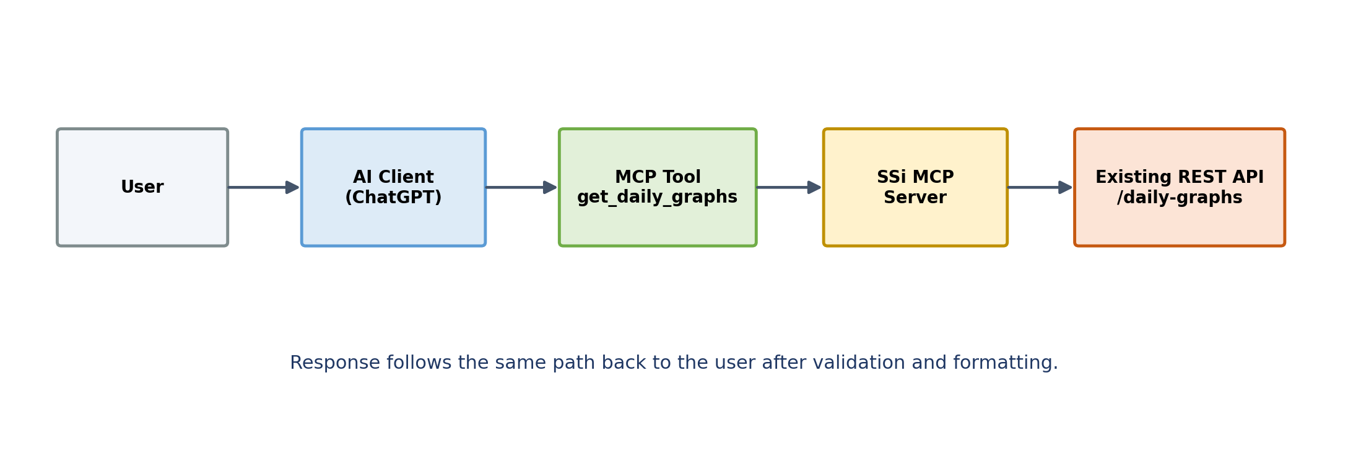
Figure 2: Request flow for a single tool call. The response follows the same path back to the user after validation and formatting.

Example: get_daily_graphs Request and Response
The following walks through one complete tool call end to end, using a sample ticker. Field names below are illustrative; the authoritative schema will live in the Tool Definitions deliverable.

1. AI Client invokes the MCP tool
{
"tool": "get_daily_graphs",
"arguments": {
"ticker": "AAPL",
"date": "2026-07-22"
}
}

2. SSi MCP Server calls the existing REST API
GET /daily-graphs?ticker=AAPL&date=2026-07-22
Authorization: Bearer <downstream-service-credential>

3. REST API response
{
"ticker": "AAPL",
"date": "2026-07-22",
"sentimentScore": 0.42,
"buzzScore": 0.71,
"narrativeTags": ["earnings", "guidance"]
}

4. MCP Server returns the result to the AI Client
{
"content": [
{
"type": "text",
"text": "{\\"ticker\\":\\"AAPL\\",\\"sentimentScore\\":0.42,\\"buzzScore\\":0.71}"
}
],
"structuredContent": {
"ticker": "AAPL",
"sentimentScore": 0.42,
"buzzScore": 0.71,
"narrativeTags": ["earnings", "guidance"]
}
}
MCP represents structured results through structuredContent. For compatibility with clients that only read content blocks, the server also serializes the same data into a text block.

Security and Error Handling
Area | High-Level Design
Client authentication | Open decision: Bearer token or OAuth, to be finalized based on the selected hosting and client integration model. Owner: engineering lead. Target: decided during Phase 1 (Foundation).
Transport security | HTTPS for all external and downstream communication.
Downstream authentication | Internal API key or existing service credential for REST API access.
Input validation | Validate required fields, ticker format, date ranges and permitted values before invoking APIs.
Secrets management | Store tokens and API keys outside source code using environment variables or a secrets manager.
Logging | Record tool name, request time, status, latency and error category; avoid logging secrets.
Error handling | Return concise, structured errors for invalid input, authentication failures, timeouts and downstream API failures.

ChatGPT Integration
At a high level, the deployed MCP endpoint is registered with ChatGPT using the authentication method supported by the selected ChatGPT integration path. ChatGPT then discovers the published SSi tools and can invoke them when a user asks a relevant question.
- Deploy a publicly reachable HTTPS MCP endpoint.
- Configure client authentication.
- Register the MCP Server in ChatGPT.
- Verify tool discovery.
- Test each tool with valid and invalid parameters.
Detailed UI steps and screenshots should be maintained separately in an Installation and Integration Guide because client configuration interfaces can change.

Deployment Architecture
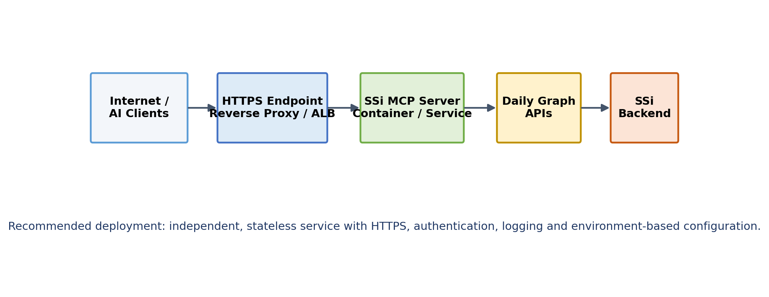
Figure 3: Deployment topology. The MCP Server runs as an independent, stateless service behind a reverse proxy / load balancer.

Deployment Characteristics
- Independent and stateless service
- Container-friendly deployment
- Environment-based configuration
- Health endpoint for monitoring
- Centralized logs and basic metrics
- Separate development, staging and production configurations

Implementation Roadmap
Phase | Outcome
1. Foundation | Implement MCP server, authentication, configuration, logging and REST client.
2. Initial Tools | Publish and test the three tools in this HLD.
3. ChatGPT Validation | Register the server, verify discovery and run end-to-end tests.
4. Hardening | Add monitoring, deployment automation, security review and operational documentation.
5. Expansion | Add more SSi tools or support additional MCP-compatible clients.

Deliverables and Success Criteria
Deliverable | Expected Output
MCP Server source code | Maintainable implementation with clear project structure.
Tool definitions | Three documented MCP tools mapped to existing APIs.
Deployment configuration | Container and environment configuration for target hosting.
Test suite | Unit, validation, error-handling and end-to-end tests.
Installation guide | Steps for deployment and ChatGPT registration.
Operations notes | Logging, monitoring, secrets and troubleshooting guidance.

Success Criteria
- All three tools are discoverable and callable from ChatGPT.
- Responses match the underlying REST API results.
- No changes are required to the existing SSi backend or business logic.
- Authentication and invalid-input handling work as designed.
- Adding a new tool requires limited, localized changes.

Design Principles
Reuse before rebuild. Keep the MCP layer thin. Validate at the boundary. Protect credentials. Return clear errors. Keep tools independently extensible. Preserve the existing SSi platform as the single source of business logic.

Glossary
Term | Definition
MCP | Model Context Protocol.
MCP Client | AI application that connects to an MCP Server.
MCP Server | Service that exposes tools through MCP.
Tool | Callable operation with a defined input and output schema.
REST API | Existing HTTP-based interface used by the SSi platform.
SSi | FinSoftAI Social Sentiment Insights platform.

Conclusion
The SSi MCP Server provides a compact, standards-based bridge between AI assistants and the existing SSi REST APIs. By keeping the server focused on protocol translation, security and operational control, the design enables rapid implementation without duplicating SSi business logic.

